

**Getting alerts sent to your telegram**

With *Commitment Alerts!* V2.03, I have implemented a way to receive commitment or chat alerts to your phone via Telegram! If you are interested in receiving these alerts, please do the following:



1. Download and set up Telegram on your phone.
2. Open a new conversation and search for @RaptorRCBot.
3. Click start and you will receive an ID.
4. Copy this ID over to the extension’s setting and click save.
5. You’re all set!

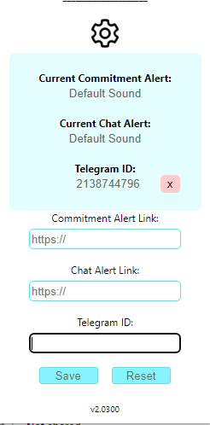Notes:

•If you install Telegram to your desktop, the notifications will be sent there instead of your phone.

•RaptorRCBot stands for Raptor Ring Central Bot.

•Don’t use my ID, it won’t work.

•Same way as the other alerts, please keep one SF window opened to receive alerts.